**“AUTOPARTXPRESS”-AUTOMOBILE SPARE PARTS APPLICATION**

Mr.Swapnil Chaudhari  
*Computer Engineering*   
*Marathwada Mitramandal’s Institute of Technology*Pune, India  
su@mmit.edu.in

Mr.Malcolm David  
*Computer Engineering*  
*Marathwada Mitramandal’s Institute of Technology*Pune  
malcolm.david@mmit.edu.in Mr.Neel Karnavat  
*Computer Engineering*  
*Marathwada Mitramandal’s Institute of Technology*Pune  
neel.karnavat@mmit.edu.in

Mr.Sahil Yerunkar  
*Computer Engineering*  
*Marathwada Mitramandal’s Institute of Technology*Pune  
sahil.yerunkar@mmit.edu.in Mr.Shiavm Dolase  
*Computer Engineering*  
*Marathwada Mitramandal’s Institute of Technology*Pune  
shivam.dolase@mmit.edu.in

*Abstract*— When it comes to owning and operating a truck, getting replacement parts is critical. This is where the revolutionary idea of a Truck Application enters the picture and transforms the spare parts procurement procedure. This application's main goal is to guarantee parts procurement, as well as their quality, dependability, compatibility, and fit accuracy. All these factors ensure that the vehicle operates at peak efficiency and performance, which adds to its effective and extended operational life. Securing original replacement parts is one of the main goals of using a truck application. Authentic replacement parts are the mark of exceptional quality and dependable dependability. As a result, truck owners may rest easy knowing that the parts they've purchased are of the best caliber. These authentic parts are painstakingly created while upholding strict quality standards. As a result, they exhibit unrivalled reliability, ensuring the apparatus's continuing usefulness and endurance. The Truck Application further highlights the importance of spare part compatibility and fit. Original replacement parts are designed to fit and perform flawlessly with the particular truck model. The exact installation guarantees peak performance in accordance with the vehicle's original specifications. This accuracy also enhances the truck's efficiency and safety, which benefits the vehicle's general functioning. The need for spare parts in the car sector is always rising due to its large and dynamic landscape. The constant inflow of spare parts is required by suppliers in their efforts to keep an adequately supplied inventory. The need of an effective and streamlined procurement system is highlighted by this growing demand. Providing for the growing needs of suppliers, the Truck Application is an essential tool. It optimizes the procurement process by offering a centralized platform for acquiring spare parts, guaranteeing a ready supply to satisfy industry demands. Keywords—Metaverse, Virtual worlds, Qualitative data analysis, Real-time communication, Virtual reality, Augmented reality.

# Introduction

An essential component of our everyday existence, the automobile industry is a monument to human creativity and development. Millions of cars make up this fleet, ranging from the family sedan that takes us on amazing road vacations to the army of trucks that keep the wheels of business spinning. But like any intricate ecology, it has difficulties, and one of the most enduring is managing and gaining access to replacement components.

Imagine this: a truck owner with a malfunction that has left them stuck on a distant highway, anxiously searching for a specific replacement component to enable them to resume their journey. Imagine a tiny garage that finds it difficult to quickly and effectively locate high-quality replacement parts so that it can service its clients. These situations are not one-off events; rather, they represent ongoing difficulties that car owners, repair shops, and the automotive sector as a whole deal with. In this sense, developing our car spare parts application was more than simply a commercial decision—it was a need that needed to be met. It is a manifestation of our dedication to simplifying, streamlining, and empowering those who depend on the automotive industry. The idea of buying spare components is known as truck application.

For truck owners, it is essential since it guarantees quality, dependability, compatibility, and proper fit. Using original spare parts guarantees better quality and dependability, giving you piece of mind and longer-lasting equipment performance. Using original replacement components that are made to fit and work flawlessly in your car, offering the best possible performance. The need from suppliers to maintain a complete inventory is driving up the need for spare parts in the automotive sector. The ultimate objective is to give dealers and customers a platform to satisfy their needs in the area of auto and replacement parts.

# LITERATURE REVIEW

Shuai Zhang, Kai Huang and Yufei Yuan (2021).[1] Recently, spare parts inventory management has been attracting more attention due to the “right-to-repair” movement which requires that manufacturers provide sufficient spare parts throughout the life cycle of their products to reduce waste so as to achieve sustainability.

Jiangang Li (2020). [2] The characteristics of automobile maintenance spare parts supply, vehicle maintenance spare parts supply and vehicle maintenance spare parts inventory management are introduced, and the current status of automobile maintenance spare parts inventory management is analysed

R. K. Malviya S. Dharmadhikari S. Choudhary, S. Gupta 1and V. Raghuwanshi (2020). [3] The objective of this study was to identify problems in the inventory management of above-mentioned firm and improving it in terms of investment, categorization of items, customer satisfaction by timely delivering what is needed and when by proposing an efficient and effective analysis.

# PROPOSED SYSTEM

Rapid Application Development (RAD) is a software development methodology that prioritizes rapid prototyping and quick feedback over long, drawn-out development and testing cycles.

* Define the requirements:

This is where rapid application development differs from traditional software development models. Instead of sitting down with end users and asking for a detailed list of specifications, you ask for a broad set of requirements. The broad set of requirements allows you to take the time to break down specific requirements at different stages of the development cycle.

* Prototype:

Here’s where the real action happens. Instead of adhering to a strict set of requirements, developers build prototypes with various features and functions as quickly as possible. These prototypes are shown to the clients, who decide what they want and don’t want. Most of the time, these prototypes are made to work quickly to showcase just the key features. This is standard. The final product isn’t created until the finalization stage, where the client and developer agree on the final product.

* Construction:

The construction phase is an important development phase. Engineers and developers work tirelessly to turn working models into working systems. Feedback and reviews are very important at this stage, and most bugs, issues, and changes are fixed at this stage. This phase can be particularly long, especially if the customer changes direction or the feedback is intense.

* Deployment:

The final phase of RAD involves deploying the constructed system into the live production environment. The implementation phase includes intensive scale test ting, technical documentation, issue tracking, final customization, and system simulation. The team also spends time debugging the app and performing final updates and maintenance tasks before going live.A truck spare part management system must prioritize security to protect sensitive data and ensure the smooth operation of a business. To achieve this, the system should enforce robust user authentication and authorization mechanisms, including strong password policies and role-based access control. Data security is paramount, and encryption should be employed for data in transit and at rest to safeguard against unauthorized access. Access control measures need to be implemented to prevent unauthorized access and common web application vulnerabilities, such as SQL injection.

In addition to protecting data, physical security considerations are crucial, and physical servers and infrastructure components should be secured against unauthorized access. Regular backups of critical data should be maintained to mitigate data loss in the event of system failures or disasters. Furthermore, having a well-defined disaster recovery plan is essential to minimize downtime and data loss in case of catastrophic failures.Vendor and third-party security is a concern, especially if the system relies on external services or components. Ensuring that third-party vendors adhere to security standards and conducting regular security assessments is vital. Secure coding practices must be followed to prevent vulnerabilities, and regular vulnerability assessments are essential to identify and address security issues promptly.

Data privacy compliance should be a priority, particularly when handling customer data.Compliance with relevant data protection and privacy regulations, as well as obtaining proper consent for data collection and processing, is essential. Security training and awareness programs should be provided to employees to educate them about security best practices and potential threats.In preparation for security incidents, an incident response plan should be developed, and all personnel should be familiar with the plan to effectively handle security incidents, including data breaches. Network security and mobile device security should also be addressed, including firewall rules, network security measures, and mobile device encryption.

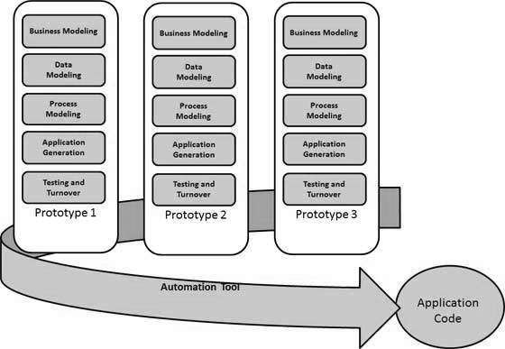

Analysis Models: RAD Model

# SYSTEM ARCHITECTURE

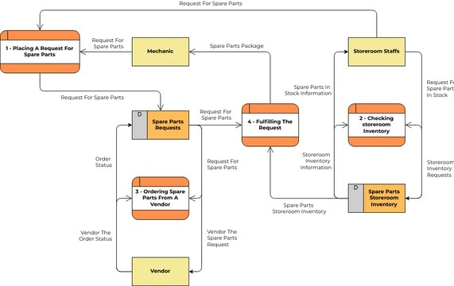

The system architecture of the automobile spare parts application is intricately designed to orchestrate a seamless and efficient process for managing spare parts requests with the utmost precision. Commencing with end-users placing requests for specific spare parts via the application's user interface, this initial step serves as the gateway to a sophisticated and well-coordinated backend operation. Upon the initiation of a spare parts request, the server undertakes a pivotal role in the system's workflow. It meticulously examines the storeroom inventory by executing queries within the database, seeking to ascertain the availability of the requested spare parts. This metro starts over from scratch. This can be a barrier to entry for both tourism providers and consumers. High barrier to entry: The current state of Meta-verse technology presents a high barrier to entry for both tourism providers and consumers. Creating high- quality Meta-verse experiences requires specialized skills and resources, and the cost of hardware and software can be prohibitive. Additionally, consumers need to have access to powerful devices and high-speed internet to participate in Meta-verse tourism. Lack of awareness and understanding: Many people are still not aware of the Meta-verse, and those who are aware of it often lack a deep understanding of its capabilities. This makes it difficult for tourism providers to market their Meta-verse experiences and for consumers to decide if they are interested in participating. Need for new business models: The Meta-verse presents new opportunities for tourism providers, but it also requires new business models. For example, tourism providers may need to consider new ways to generate revenue, such as through the sale of virtual goods and services. Additionally, tourism providers may need to partner with other businesses, such as technology companies and social media platforms, in order to create successful Meta-verse experiences. Wonders

# DATA FLOW DIAGRAM

fig: Data Flow Diagram

The meticulously crafted system seamlessly navigates through the procurement process of spare parts from the headquarters. The journey initiates with the acquisition of spare parts, followed by a judicious query into the inventory database. This strategic interrogation serves as a critical checkpoint to assess whether the inventory is adequately stocked. Should the inventory meet the requirements, the system gracefully proceeds to the release of a delivery order, orchestrating the subsequent journey of the spare parts. The carefully curated path directs the delivery towards service stations, acting as pivotal hubs, and ultimately culminating in the seamless dispatch to the client's designated address. It unfolds with a similar procurement initiation, marking the purchase of spare parts from headquarters. The system's astute design prompts an immediate inquiry into the inventory database, evaluating its sufficiency. If the inventory proves to be deficient, a nuanced decision-making node surfaces, posing the question, "Do You Need to Order?" Depending on the response, a conditional pathway is determined. In the event of a negative response, a command to declare "Out of Stock" is released, initiating appropriate measures. It is distinguished by its nuanced complexity, beginning with the acquisition of spare parts from the headquarters. A meticulous scrutiny of the inventory database ensues, discerning its adequacy. If the inventory falls short, an intricate decision-making juncture emerges, posing the question, "Do You Need to Order?" The affirmative response triggers a sophisticated sequence, orchestrating the procurement of spare parts from a designated supplier. The subsequent phases involve the dissemination of these parts to major hubs, epitomized by handling procedures and the dispatch to service stations. The culmination of this intricate journey is the delivery of spare parts to the client's address, facilitated through the strategically positioned service stations. Each step in this elaborate scenario is underscored by a commitment to precision and diplomatic orchestration, ensuring a smooth and reliable spare parts procurement and distribution process.

# RESULTS

USER INTERFACE:

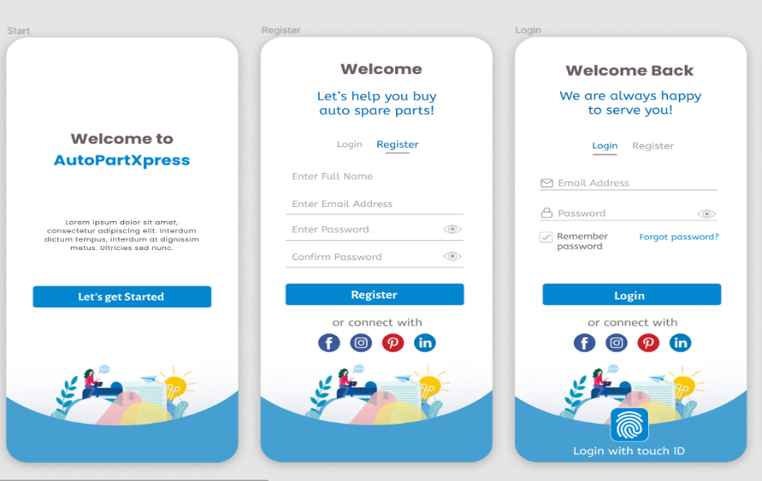 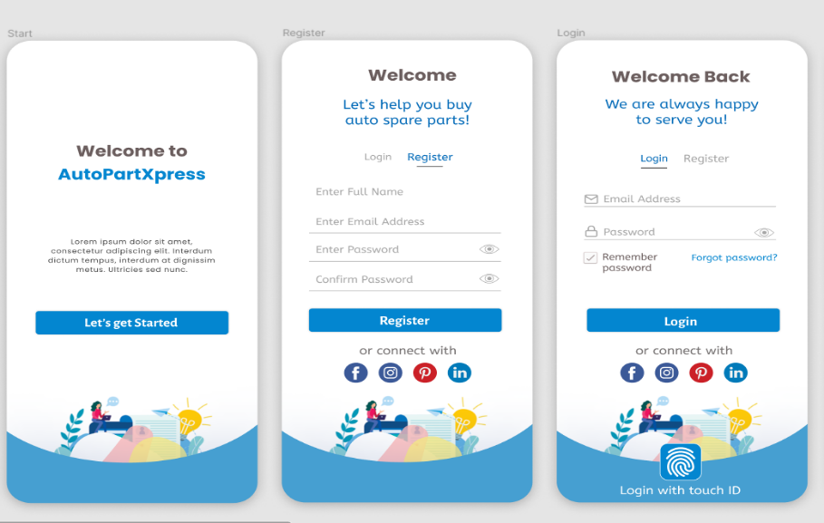

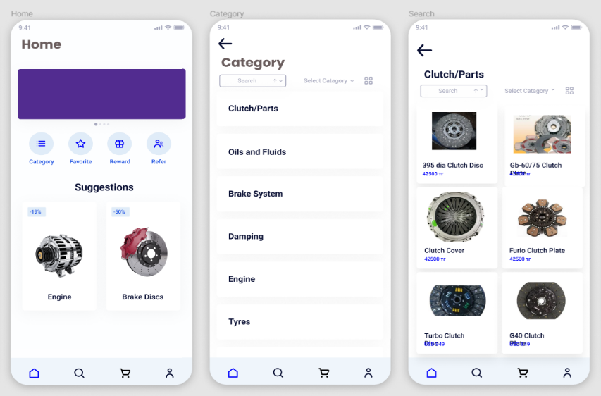

# FUTURE SCOPE

The future of car spare parts application is full of exciting possibilities, ready to take advantage of the changing tech landscape and the car industry. AI and ML are key tools to make predictive maintenance easier, predict demand better, and give users personalized advice. User experience is a top priority, with ideas for new design, VR or AR for immersive interfaces and keeping mobile responsive. IoT devices can be used to track spare parts in real-time, keep track of car health, and send maintenance alerts. Blockchain technology could make spare parts more authentic, reducing the risk of fake products. With global expansion, localization, and e-commerce partnerships, the app's reach could expand even more. As mobile tech evolves, future improvements could include adding new features, making performance better, and

making sure the app is compatible with the newest operating systems.The use of powerful data analytics tools could provide businesses with valuable insights to guide decision-making. Sustainability, partnerships with industry players, and cybersecurity measures emphasize a holistic and forward-thinking approach to the project’s future development. The project’s success depends on its ability to adapt to industry dynamics, ongoing innovation, and a consistent focus on user experience.

# CONCLUSION

Above all, our product solves a significant and persistent problem rather than just providing a digital platform. It is a response to the complaints of innumerable car owners and repair shops who have struggled with the uncertainty and inefficiencies of finding replacement parts. Through the development of this application, we have facilitated easier, more transparent, and more convenient access for users to the spare components they require. Furthermore, the cornerstone of our application is our dedication to openness. Without the uncertainty and discrepancies in cost that frequently afflict the automobile replacement parts industry, users are able to make well-informed judgements. We think that every user should have access to the appropriate spare parts at the appropriate time and price, irrespective of their location or level of experience. We are significantly enhancing the larger automotive ecosystem in the process of developing this application. Through enabling car owners and service providers, we contribute to the general well-being of the automotive industry. In addition to supporting the industry, this promotes repair and maintenance over the premature disposal of vehicles, so contributing to environmental sustainability. Our application aims to improve user experience and apply technology to address practical issues, not only write code. We are confident in the future of the automotive industry and its digital transformation, and we are committed to helping our users remain ahead of the curve in the ever-evolving world of technology and accessibility. In conclusion, we are more than just a software solution; we are committed to providing our users with a dependable, transparent, and accessible platform to meet their automotive spare parts needs.

##### References

1. Apple Inc. iPhone 12 Product Environmental Reports. Available online: http://www.apple.com/environment/ (accessed on 14 December 92020)
2. Togwe, T.; Eveleigh, T.J.; Tanju, B. An additive manufacturing spare parts inventory model for an aviation use case. Eng. Manag. J.(2019)
3. Kennedy, W.J.; Patterson, J.W.; Fredendall, L.D. An overview of recent literature on spare parts inventories. Int. J. Prod. Econ.(2019)
4. Chen, H.; Chiang, R.H.L.; Storey, V.C. Business intelligence and analytics: From big data to big impact. MIS Q (2019)
5. Van der Auweraer, S.; Boute, R. Forecasting spare part demand using service maintenance information. Int. J. Prod. Econ. (2019)
6. Frandsen, C.S.; Nielsen, M.M.; Chaudhuri, A.; Jayaram, J.; Govindan, K. In search for classification and selection of spare parts suitable for additive manufacturing: A literature review. Int. J. Prod. Res. (2020)
7. Den Boer, J.; Lambrechts, W.; Krikke, H. Additive manufacturing in military and humanitarian missions: Advantages and challenges in the spare parts supply chain. J. Clean. Prod (2020)
8. Van Wingerden, E.; Tan, T.; Van Houtum, G.J. The impact of an emergency warehouse in a two-echelon spare parts network. (2019)